**Integrating Daytrades With HTF Trade Entries**

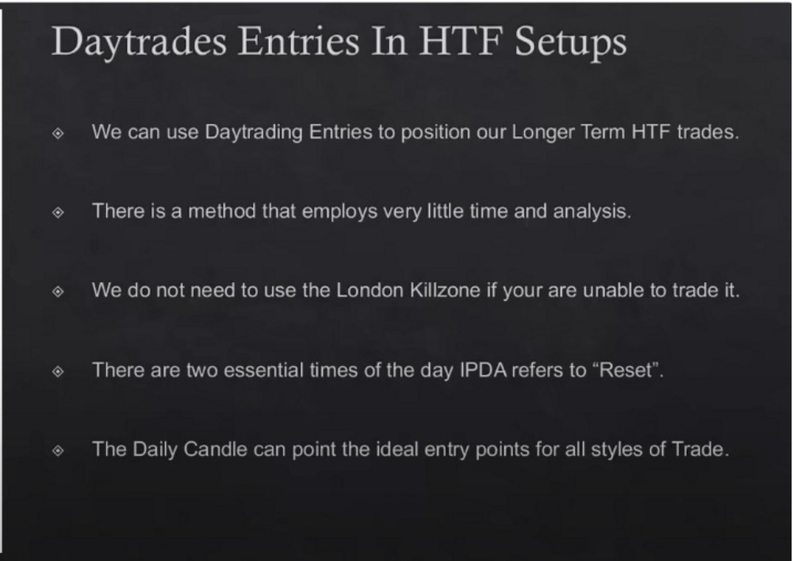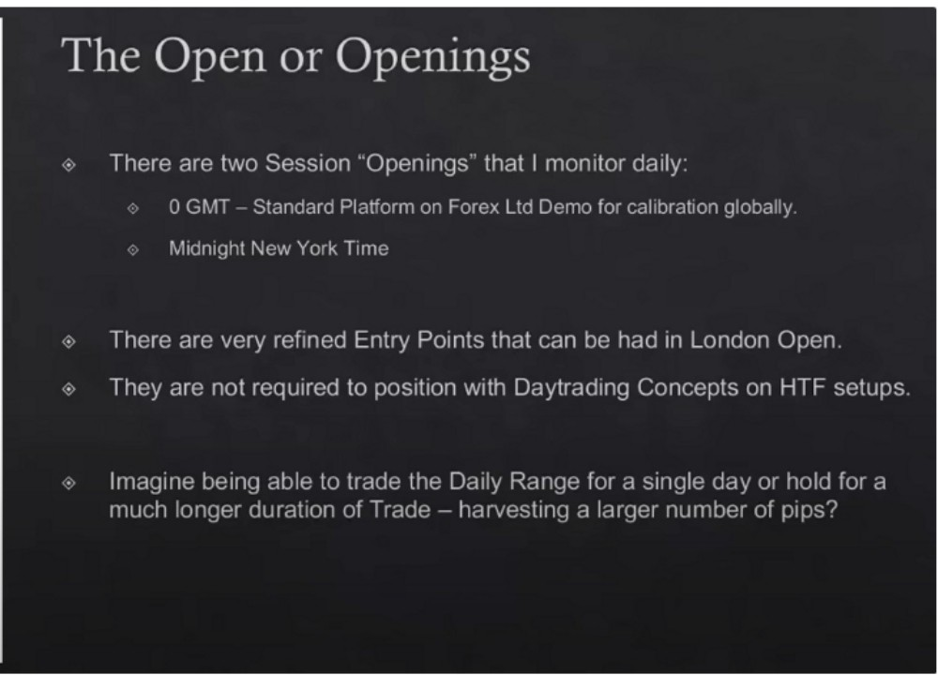

**Power Of Three**

Typically it closes near the high of the day on a bullish day, vice versa for a bearish day. Open decline downclose, or open rally upclose

It closes near the extremes typically

This is for when you cant trade london killzone

**Power Of Three**

You dont need the refined london open entries

If you understand IPDA and the daily range, and understand where were coming from on the PD array matrix, are we moving from a discount up into a premium? Or vice versa? Knowing that gives us a directional bias and wether we want to be a buyer or seller.

**Power Of**

**Power Of Three**

**Three**

The daily candle at O GMT thats our beginning reference point for IPDA thats true day opening MNO is true day open

How much lower from an opening will it go before we get an upclose? And how much higher will it go when it is a downclose?



**Premium Array**

**Power Of Three**

**Discount Array**

The key is knowing where youre at on the HTF PD array matrix, it has to already respect a discount array its failing to go lower its repelling and the next day we expect very little downside movement

All we need to know if is were likely going higher or lower



**OGMT**

**London Protraction**

We have to see price already respected a daily discount PD array and then the next day you look at O GMT opening price

At O GMT you know what the CBDR is going to provide you Buy at O GMT

It could potentially be a 90 or 100 pip stops, but thats okay because this is using daytrading concepts to get in a HTF trade idea. Were looking for several 100 pips of profit. We hold it until we trade into a premium array



**OGMT**

**BuyAtOGMT**

**Use 5 Day ADR As Stop**

**OGMT**

I

? **London Protraction**

We dont know how much the protraction will be, the key is that we have already seen price moving away from a premium array on the daily chart the day before

**Q GMT J=I=** SellAt0GMTOpen

Use *5* Day ADR As Stop

Plus 20 Pips

Use *5* Day ADR As Stop

**OGMT**

Sell At 0 GMT Open

With this we expect a little bit of protractionary move, use a sell limit

If you dont want to miss the move, you can risk half by immediately executing at O GMT and half risk at 20 pip limit

**Homework**



Use ATR indicator on the last 5 days if you dont have the ICT indicator

Arjo I Twitter, lnstagram I Linktree

Linktree. Make your link do more.

1 https://t.co/HhmmTN1fUI

JavaScript is not available.

'I# https://twitter.com/arjoio